**Software Requirements Specification**

**for**

CAK Catering

**Version 1.0 approved**

**Prepared by Carlos Cruz Serrano, Kevin Murray, and Ahnaf Sindid**

**Farmingdale State College**

**March 2, 2025**

**Table of Contents**

**1. Introduction 1**

1.1 Purpose 1

**1.2 Document Conventions 1**

**1.3 Intended Audience and Reading Suggestions 1**

**1.4 Product Scope 1**

**1.5 References 1**

**2. Overall Description 2**

2.1 Product Perspective 2

**2.2 Product Functions 2**

**2.3 User Classes and Characteristics 2**

**2.4 Operating Environment 3**

**2.5 Design and Implementation Constraints 3**

**2.6 User Documentation 3**

**2.7 Assumptions and Dependencies 3**

**3. External Interface Requirements 3**

3.1 User Interfaces 3

**3.2 Hardware Interfaces 7**

**3.3 Software Interfaces 7**

**3.4 Communications Interfaces 7**

**4. System Features 8**

**4.1 Customer: View Menu 8**

4.2 Customer: Suggest New Item for the Menu 9

4.3 Customer: Get a Quote for an Order 10

4.4 Customer: Place an Order 11

4.5 Customer: Submit Customer Support Inquiry 13

4.6 Customer: View Order History 14

4.7 Customer: Cancel Order 16

4.8 Customer: Edit Order 17

4.9 Customer: Leave a Review 18

4.10 Customer: Message with Artificial Intelligence Chatbot 19

4.11 Admin: Admin Directory 20

4.12 Employee: Inventory Chart 21

4.13 Employee: Schedule 22

4.14 Employee: Schedule Order Details Window 23

4.15 Employee: Contacts Page 24

4.16 Employee: Contacts Support Window 25

4.17 Employee: Orders Chart 26

4.18 Employee: Order Details within Orders Chart 27

**5. Other Nonfunctional Requirements 29**

5.1 Performance Requirements 29

**5.2 Safety Requirements 29**

**5.3 Security Requirements 29**

**5.4 Software Quality Attributes 29**

**5.5 Business Rules 29**

**Revision History**

| **Name** | **Date** | **Reason For Changes** | **Version** |
| --- | --- | --- | --- |
| CAK Catering | 3/2/2025 | Adding initial requirements and specifications | 1.0 |
|  |  |  |  |

# **Introduction**

## **Purpose**

The purpose of this document is to showcase a description of the CAK Catering software. It will explain the purpose and features of the software, the interfaces of the software, what the software will do and the requirements in order to run it. This document is intended for users of the software and also potential admins.

## **Document Conventions**

This Document was created based on the IEEE template for System Requirement Specification Documents

## **Intended Audience and Reading Suggestions**

* Typical Users, this would be customers that are interested in placing a catering order
* A more professional user would be employees, who will have control over the orders themselves and make them
* Admministrative users, who will have control of the backend of the software and also be able to delete and create users

## **Product Scope**

CAK Catering is a software for people interested in order catering services and exploring the variety of foods this business has to offer. Customer users can place order, leave reviews, suggest certain foods to the menu, view the schedule to know when the catering services are available, and even ask employees questions or an AI chat bot for help. Employees can use the software to view when orders are being placed, how much inventory they have, reply to questions and much more. While Admins will have more control of the backend and be able to block off certain dates and delete/create users. This program is meant for those interested in catering services or even getting involved in the business.

## **References**

<https://github.com/kevinmurray2330/csc325capstone.git>

<https://mylearning.suny.edu/content/enforced/643334-2023FA-FAR-CSC325-92915/Example02_gephi_srs_document.pdf>

# **Overall Description**

## **Product Perspective**

CAK Catering to streamline the operations of a catering company. The program is able to manage the company’s schedule of orders and inventory of ingredients, while making the ordering process easier for customers.

The team of developers is available to answer any questions or concerns from users. Users with computers using Windows, macOS, and Linux operating systems can run the program.

## **Product Functions**

Functions within this program are specific to the class of the user.

Customers can:

* Place an order for pick-up at a time and date that is not already at its maximum booking capacity
* Get a quote for an order
* Review their previous and upcoming orders
* Cancel or edit their orders within 24 hours of their scheduled pick-up time
* Leave reviews with pictures for items that they have previously ordered
* Submit suggestions for items to be added to the menu with pictures
* Submit questions to be answered by an employee at a future time
* Ask an artificial intelligence chatbot questions to be answered immediately

Employees can:

* View the schedule of upcoming orders
* Cancel or edit upcoming orders on behalf of customers
* Mark orders as picked-up after the customer picks up their order
* Respond to questions and concerns submitted by customers
* View and edit the inventory of ingredients

Admins can:

* Add or delete customer and employee accounts
* Edit, add, or remove menu items
* Block off specific dates and times during which orders cannot be placed
* Enable and disable the artificial intelligence chatbot

## **User Classes and Characteristics**

There are 3 classes of users: customers, employees, and admins. Customers will be individuals interested in ordering from the catering company. Employees will be people working at the catering company. Admins will be the owners of the catering company. Each class of user has a specific set of functions, as listed in section 2.2.

## **Operating Environment**

CAK Catering runs on computers with:

* Windows 10
* Windows 11
* macOS 13
* macOS 14
* macOS 15
* Linux

## **Design and Implementation Constraints**

The Java files for this program were written in the IntelliJ IDE, and the JavaFX files were edited in SceneBuilder.

## **User Documentation**

A tutorial video with demonstrations is provided with the software.

## **Assumptions and Dependencies**

CAK Catering’s software is written in Java. The user’s computer must have version 7 or higher of Java installed in order for the program to run.

# **External Interface Requirements**

## **User Interfaces**

1. Register Screen. Must Select the type of user you are using an honor system do depict the purpose of registering your account.

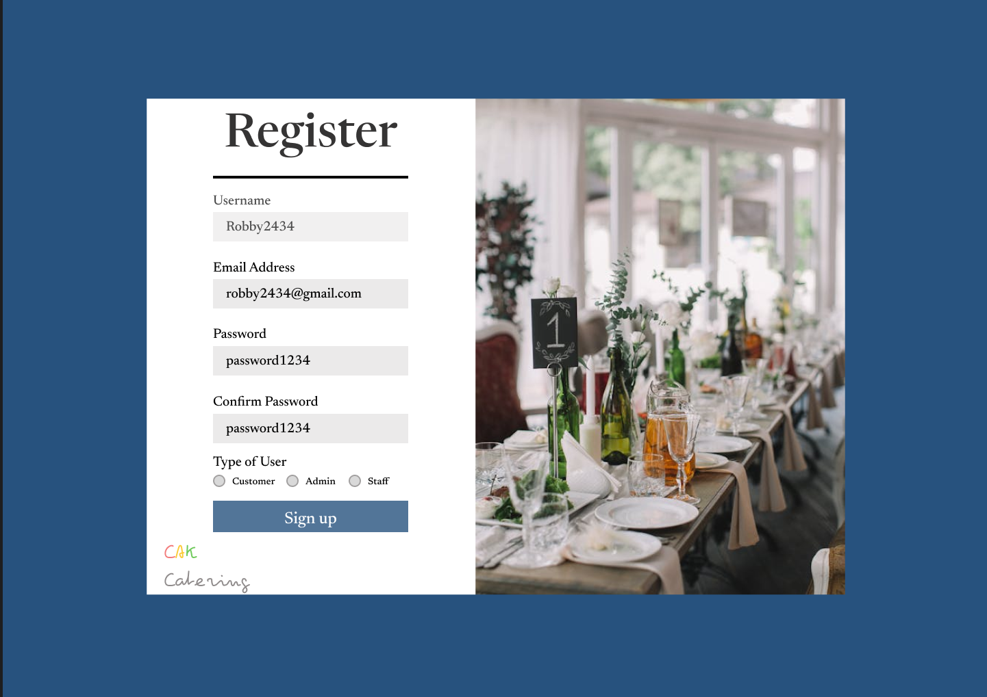

1. Sign In Screen. If there is no account, must click URL on bottom of page which will direct you to the registration page.

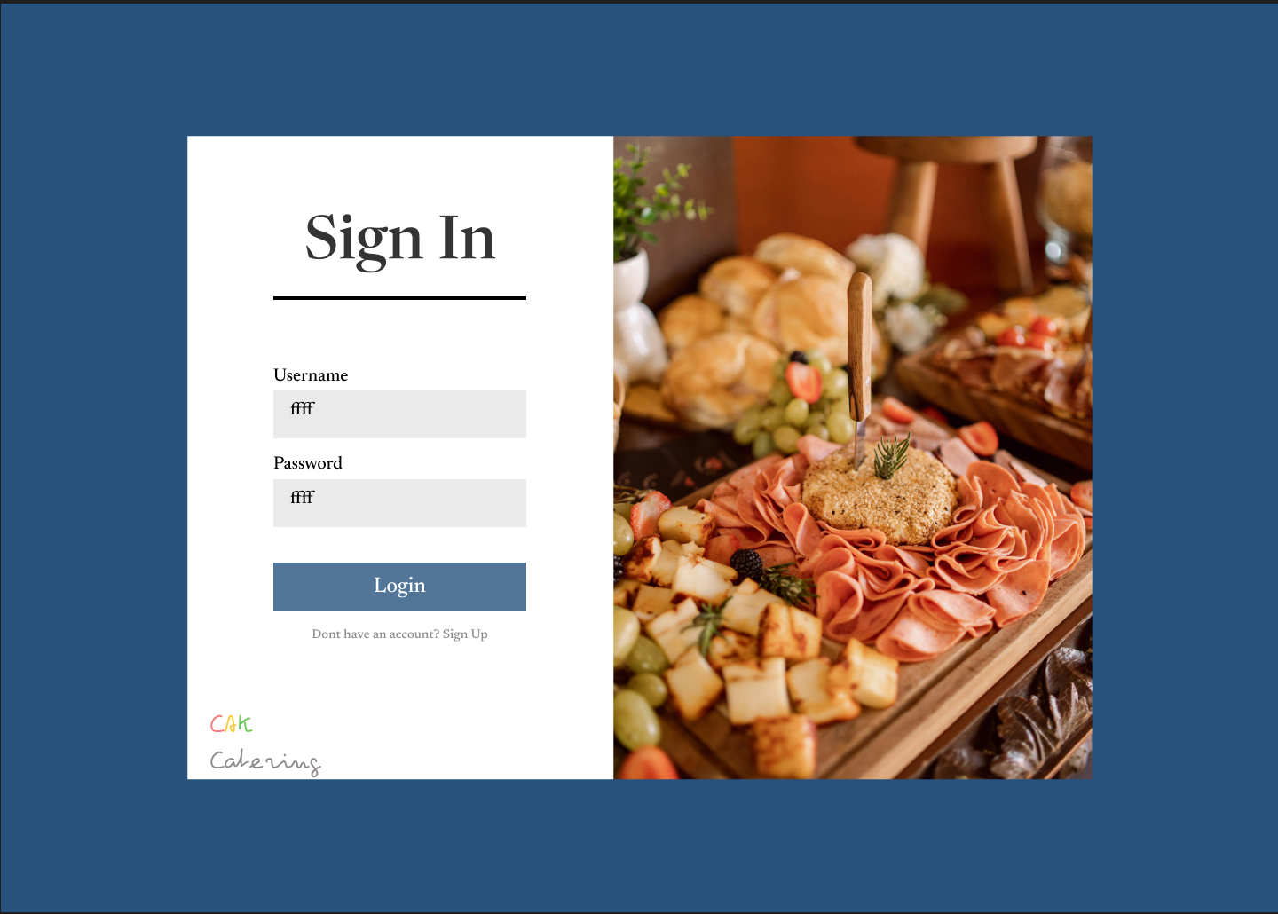

1. Employee Homepage. Each label on the left is a button that will direct you to the according label. Schedule will take you to the schedule screen, inventory will take you to the inventory screen, orders will take you to the order screen, contacts will take you to the contact support screen, and log out will log you out of the account and redirecting you to the sign in page.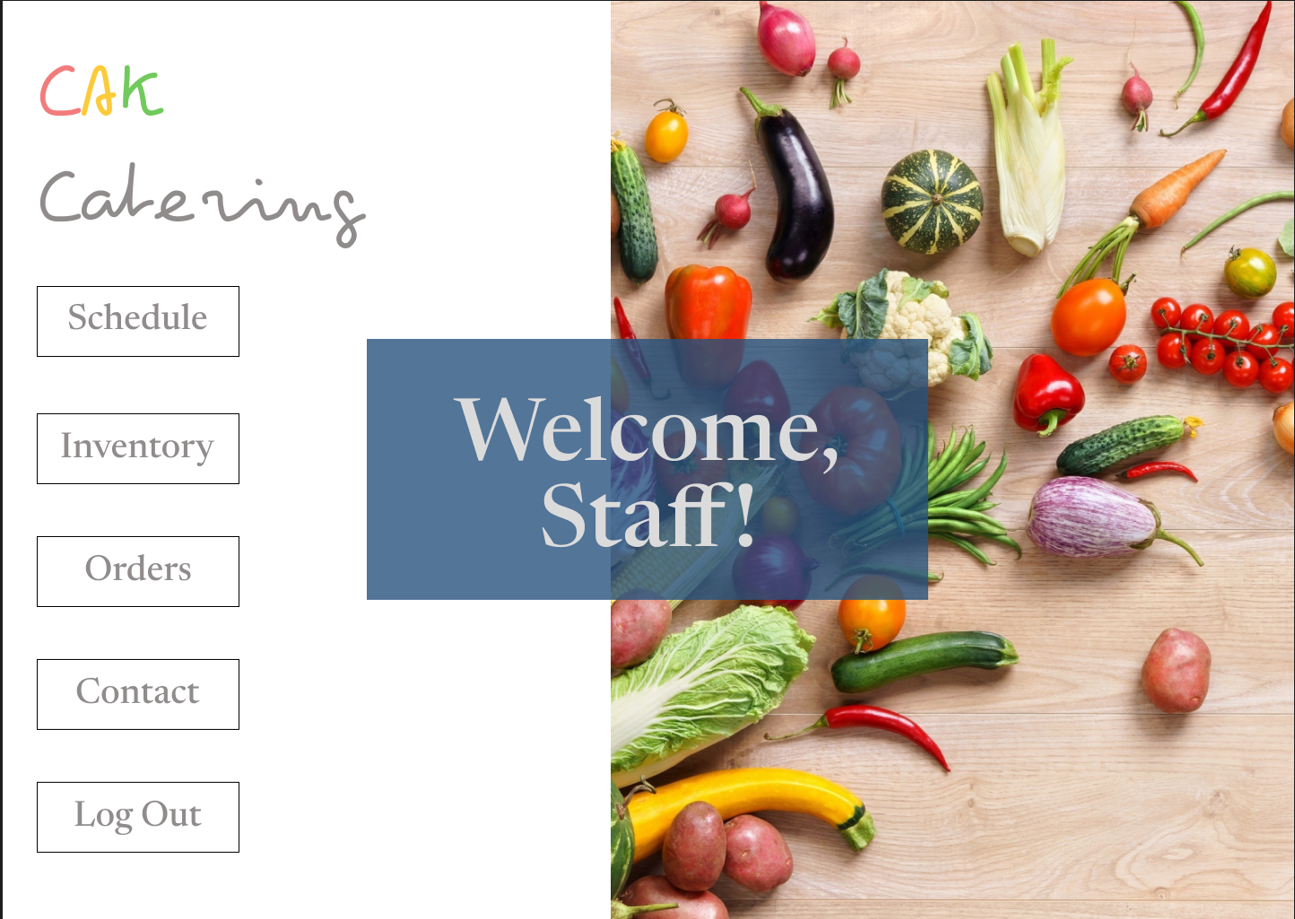

1. Customer Homepage. Each label on the left is a button that will direct you to the according label. Orders will take you to the orders page. Get a quote will take you to the quote poage to get a quote on your placed order. Catering menu will direct you to the menu screen which displays all the meals with a description and price for customers. Contacts will direct you to the support page. Order history will direct you to your orders placed. Also the robot on teh bottom left will redirect you to an AI chat bot to answer less specific and more general questions Lastly log out will log you out of the account and redirecting you to the sign in page.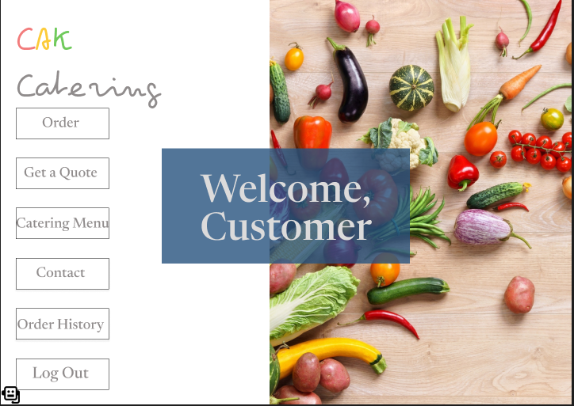

## **Hardware Interfaces**

CAK Catering requires a system with minimum 8 GB of RAM, intel Core i3 or AMD Ryzen 5. For storage, a solid-state drive(SSD) is recommended along with a graphics card for better performance.

## **Software Interfaces**

CAK Catering requires Java to be installed on your system.

## **Communications Interfaces**

CAK Catering requires you to have an email to create an account and also have an internet connection so that the chatbot and support page may work.

# **System Features**

Each feature is specific to a user class: customer, employee, or admin. Each feature title will specify which user class can perform the feature.

## Customer: View Menu

4.1.1 Description and Priority

This feature allows customers to scroll through the menu and see the descriptions, prices and images of each item

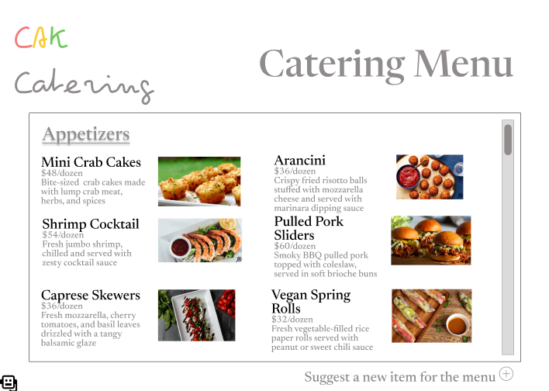

4.1.2 Stimulus/Response Sequence

The user can click the magnifying glass button in the bottom right corner of each image to see a larger version.

4.1.3 Functional Requirements

The user needs to be able to scroll up and down the menu using the scroll bar on the side of the screen or the up and down arrows. All of the menu items and corresponding information are stored in a database.

## Customer: Suggest New Item for the Menu

4.2.1 Description and Priority

This feature allows customers to suggest a new item to be added to the menu.

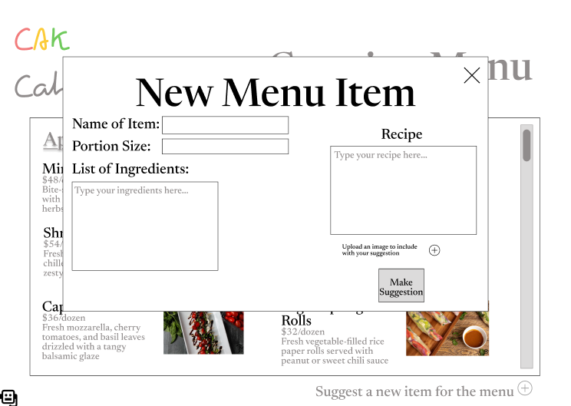

4.2.2 Stimulus/Response Sequences

Users can add text in the text boxes. They can also include a photo with their suggestion by pressing the “+” button under the Recipe box. The pop-up window can be closed by pressing the “X” button in the top right corner. The suggestion can be submitted by pressing the “Make Suggestion” button.

4.2.3 Functional Requirements

The program will only let the user submit the form if there is text in all 3 text boxes. Including a photo with the suggestion is optional. Suggestions will be stored in a database to be reviewed and possibly added to the menu.

## Customer: Get a Quote for an Order

4.3.1 Description and Priority

This feature allows users to get a quoted price for an order by selecting the quantity of items that they would like to order without choosing a time and date for the order to be picked up. Once the user has a quote for their order, they can choose to place the order.

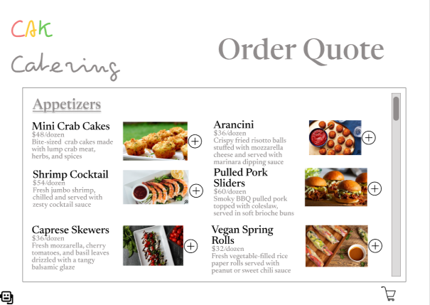

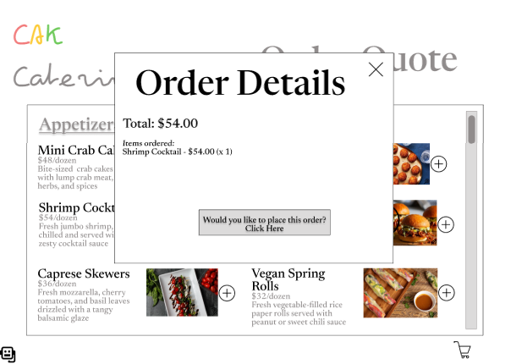

4.3.2 Stimulus/Response Sequences

The user can add an item to their shopping cart by pressing the “+” button next to the item on the menu. They can add more than one of any item by clicking the “+” more than once. Clicking the shopping cart button in the bottom right corner of the screen opens a pop-up window with the order details, which can be closed by clicking the “X” in the top right corner. The customer can choose to make it an official order by clicking the “Would you like to place this order? Click Here” button.

4.3.3 Functional Requirements

The total of the quoted order will be calculated by multiplying the quantity of each item ordered by each item’s price.

## Customer: Place an Order

4.4.1 Description and Priority

This feature will allow customers to place an order to be picked up at a future time and date.

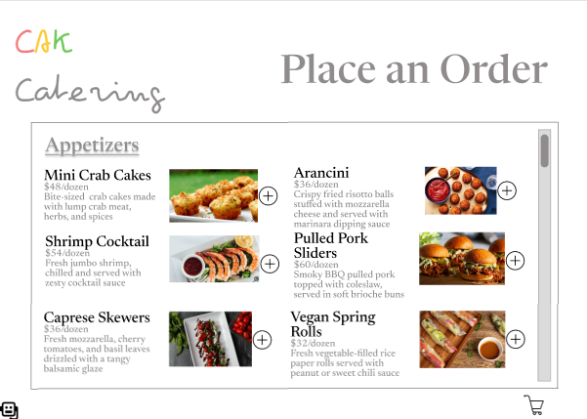

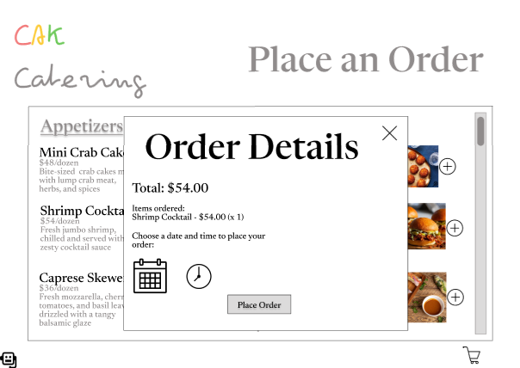

4.4.2 Stimulus/Response Sequences

The user can add an item to their shopping cart by pressing the “+” button next to the item on the menu. They can add more than one of any item by clicking the “+” more than once. Clicking the shopping cart button in the bottom right corner of the screen opens a pop-up window with the order details, which can be closed by clicking the “X” in the top right corner. Then, the customer will need to select a time and date to pick up their order by clicking the calendar and clock buttons. They will not be able to select times and/or date that have been fully booked.

4.4.3 Functional Requirements

The schedule of upcoming orders will be stored in a database. Before allowing a user to select a time and date for their pick up, the system will check which times and dates are completely booked and only show the customer available options. Once the user place their order, it will be added to the order database.

## Customer: Submit Customer Support Inquiry

4.5.1 Description and Priority

This feature allows customers to submit questions and concerns to be reviewed and responded to by employees.

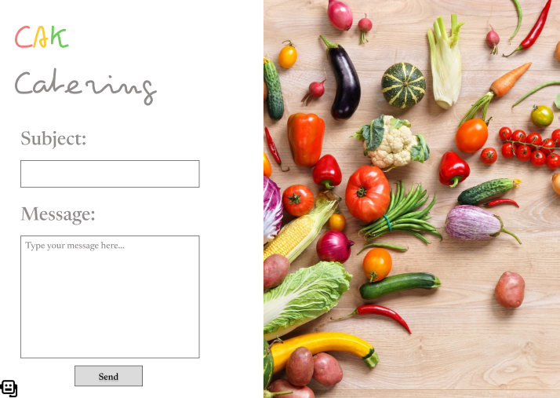

4.5.2 Stimulus/Response Sequences

The user can type in the two text boxes and submit the message by clicking the “Send” button.

4.5.3 Functional Requirements

The user will only be able to send the message if there is text in both text fields. When an employee responds to the customer’s inquiry, the response will go to the email address of the customer’s account.

## Customer: View Order History

4.6.1 Description and Priority

This feature allows the customer to view a table with key information from their previous orders. They can see orders that have already been picked up or orders that are for a future time and date.

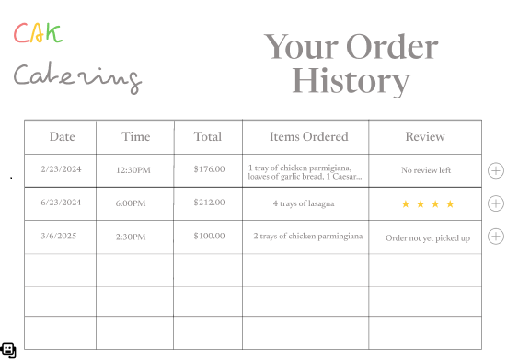

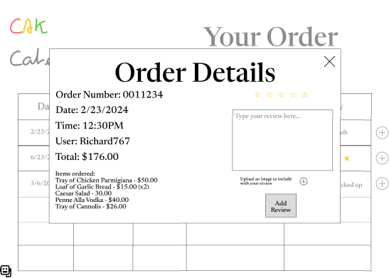

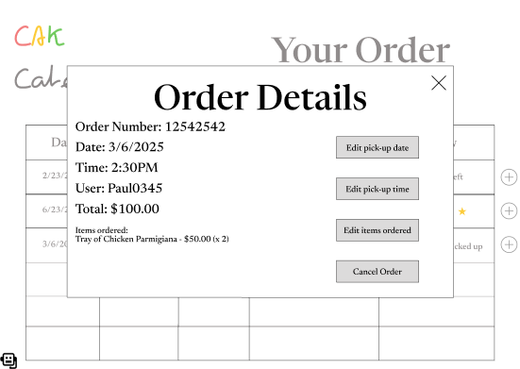

4.6.2 Stimulus/Response Sequences

By clicking the “+” button next to any individual order, they will bring up a pop-up window with their order details and buttons for other features. The pop-up window can be closed by clicking the “X” in the top right corner. If the order has already been picked up, the pop-up window will either show a review for the order already left by the customer or give the customer an option to add a review. If the order is for a future time and date, the pop-up window will give the customer options to cancel or edit their order.

4.6.3 Functional Requirements

To populate the table with a customer’s order history, the system will pull orders from the orders database that were placed by the customer. If a customer has not placed any orders yet, they will see a blank table.

## Customer: Cancel Order

4.7.1 Description and Priority

This feature allows users to cancel orders that they have previously placed but have not yet picked up a minimum of 24 hours before the scheduled pick-up time.



4.7.2 Stimulus/Response Sequences

Clicking the “Cancel Order” button submits the cancellation request.

4.7.3 Functional Requirements

Cancelled orders will be deleted from the orders database. When the customer presses the “Cancel Order” button, the system will ensure that it is at least 24 hours before the scheduled pick-up time. If it is less than 24 hours before the scheduled pick-up time, the system will notify the customer that the cancellation cannot be processed.

## Customer: Edit Order

4.8.1 Description and Priority

This feature allows users to edit the details of orders that they have previously placed but have not yet picked up a minimum of 24 hours before the scheduled pick-up time.



4.8.2 Stimulus/Response Sequences

When the user clicks the “Edit pick-up date” button, they will be brought to a screen to pick a new date for their order. When the user clicks the “Edit pick-up time” button, they will be brought to a screen to pick a time for their order. When the user clicks the “Edit items ordered” button, they will be brought back to the catering menu to re-add items to their cart.

4.8.3 Functional Requirements

Orders that are edited will be amended in the orders database. When the customer presses any of the “Edit” buttons, the system will ensure that it is at least 24 hours before the scheduled pick-up time. If it is less than 24 hours before the scheduled pick-up time, the system will notify the customer that the order cannot be edited.

## Customer: Leave a Review

4.9.1 Description and Priority

This feature allows customers to place reviews for orders that they have already picked up. The customer must rate the order from 1-5 stars and write a brief message. They can also include a picture with their review.



4.9.2 Stimulus/Response Sequences

Users can click between 1 and 5 of the stars and type in the text box. When a star is selected it will fill with yellow. Clicking the “Add Review” button submits the review. A photo can be added to the review by clicking the “+” button.

4.9.3 Functional Requirements

Reviews will be kept in a reviews database. Customers will only be able to submit their review if they have selected a rating from 1-5 stars and added text. Pictures are optional to include with reviews.

## Customer: Message with Artificial Intelligence Chatbot

4.10.1 Description and Priority

This feature allows customers to speak with an artificial intelligence chatbot to ask questions.

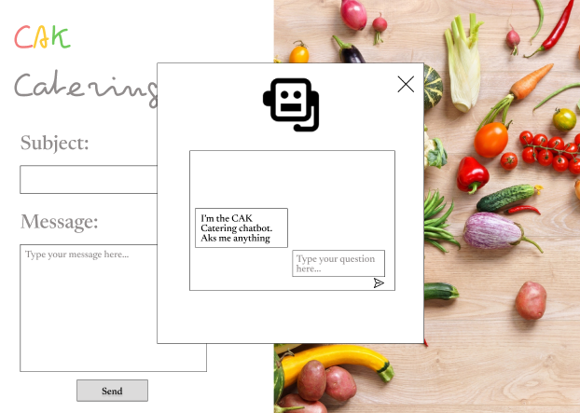

4.10.2 Stimulus/Response Sequences

The chatbot can be accessed by clicking the robot button in the bottom left corner of any screen. Once clicked, a pop-up window will open with a text box for the user to type their question. They can send their message by clicking the arrow button under the text box. The pop-up window can be closed by clicking the “X” in the top right corner.

4.10.3 Functional Requirements

The chatbot uses artificial intelligence to answer user questions.

## Admin: Admin Directory

4.11.1 Description and Priority

The Admin dashboard showcases a chart in the center displaying all users and their roles. On the left there is different buttons that direct the user to different pages displayed by the other roles already.

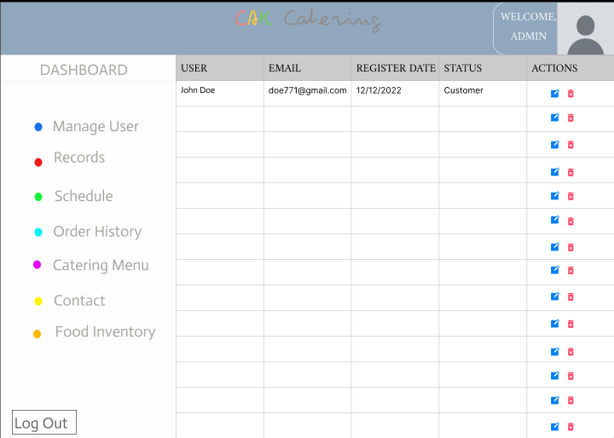

4.11.2 Stimulus/Response Sequences

To arrive at the directory you must have the admin role when signing in. The blue icons allow you to edit a user's role and the red bin deletes the user from the database, this includes any orders they may have placed. The catering menu will showcase the menu offered to customers. While the contact, orders, inventory, and schedule all will all show the same corresponding screens as employees. Lastly the admin may log out using the log out button on the bottom left of the screen.

4.11.3 Functional Requirements

Users must be entered within the database for their roles to be edited or be removed from the database.

## Employee: Inventory Chart

4.12.1 Description and Priority

This screen shows the various ingredients in stock and all the details related to these ingredients such as the quantity in stock, how much is needed, the purchase and expiration dates, and the category and type of food.

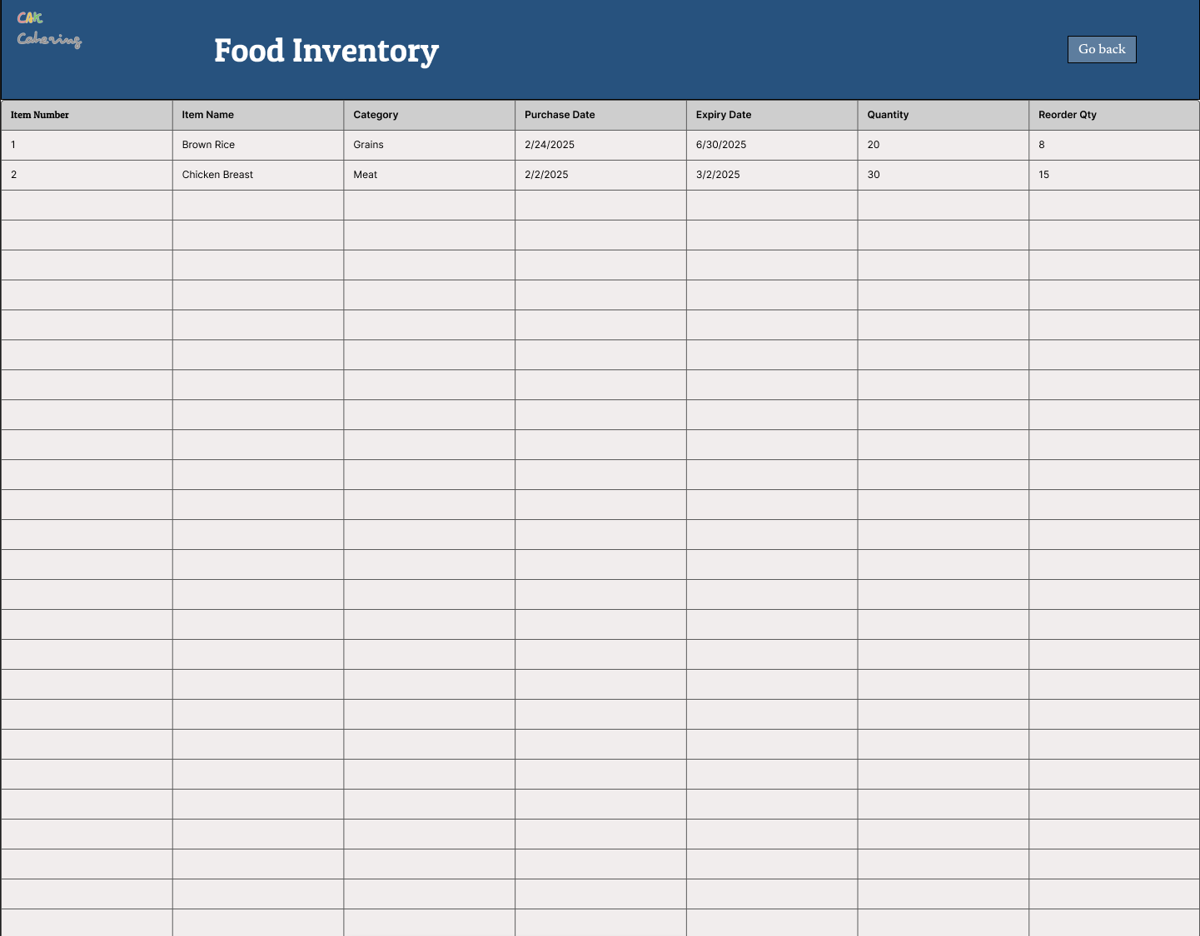

4.12.2 Stimulus/Response Sequences

To enter ingredients into the food inventory, you simply click on an open row and enter the information corresponding to the column. To go back to the home screen, click “Go Back in the top right of the screen”.

4.12.3 Functional Requirements

Once an ingredient has been entered, it will be stored in the database for recipes and meals on the menu.

## Employee: Schedule

4.13.1 Description and Priority

The Schedule allows staff to view when upcoming orders are due, and the details of upcoming orders as well.

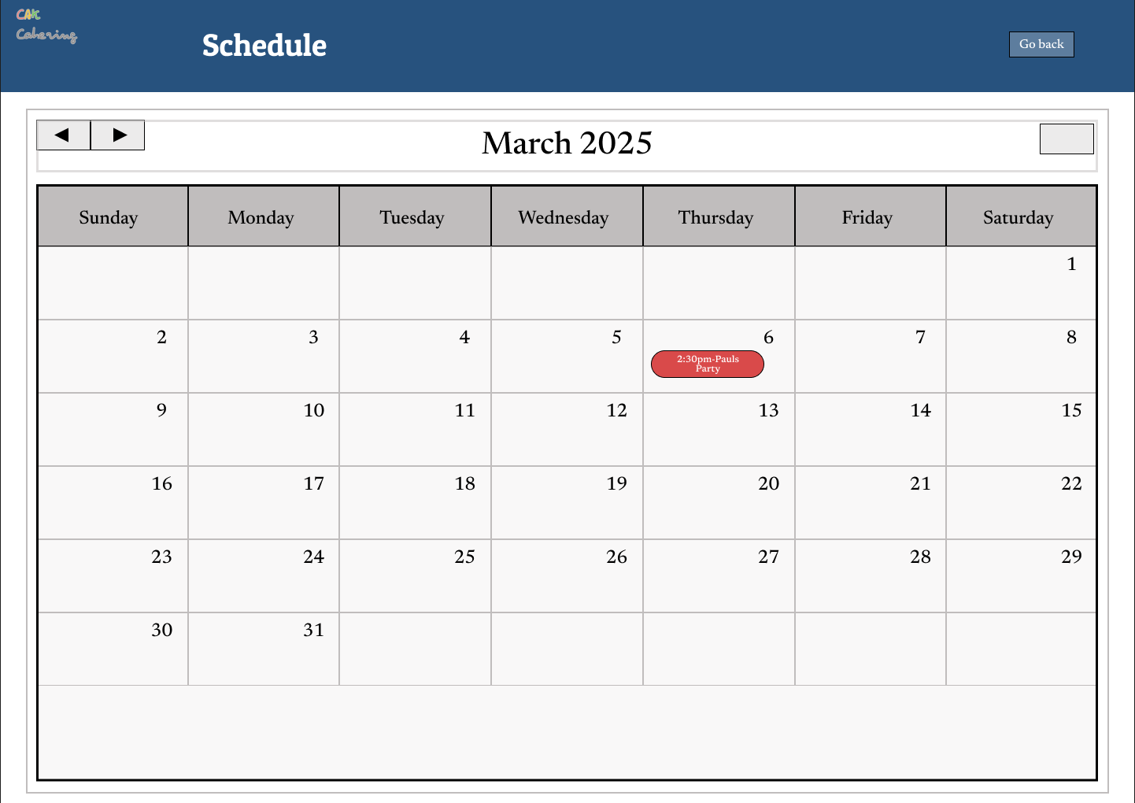

4.13.2 Stimulus/Response Sequences

Must click the Schedule button to arrive to this screen. The arrows will take you to previous months or future months to view when orders are due. The highlighted tabs on the calendar are events for when orders are due. They are clickable to expand the order. To go back to the home screen, click “Go Back in the top right of the screen”.

4.13.3 Functional Requirements

Customer must place an order for a highlighted tab to appear on the calendar. Once the order is complete, the tab will turn green.

## Employee: Schedule Order Details Window

4.14.1 Description and Priority

Employee may view the order details on the schedule page

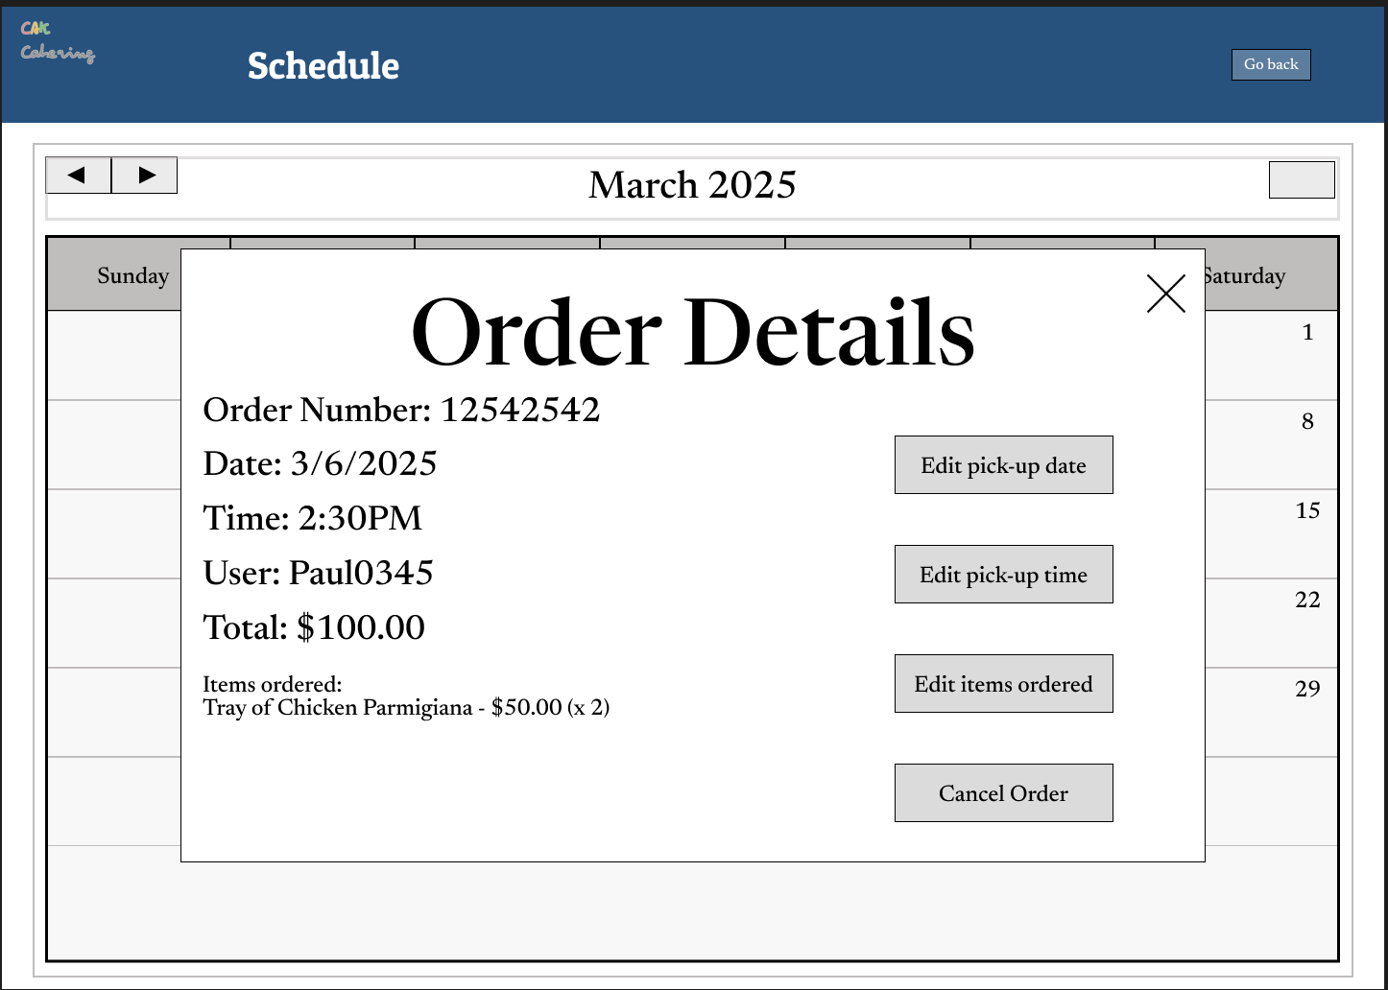

4.14.2 Stimulus/Response Sequences

Must click on the highlighted oval on the calendar to view order details. Staff will be able to edit the pick up date or time, while also be able to edit the items

ordered by the user. They may also cancel the order within this tab. This will remove

it from the Schedule.

4.14.3 Functional Requirements

Requires for an order to be placed by a customer so that it can grab information from the database for it to be placed in the window

## Employee: Contacts Page

4.15.1 Description and Priority

Employees can view the list of support request on the chart to see who the customer is, their email, when they sent the request, and whether or not it’s been satisfied.

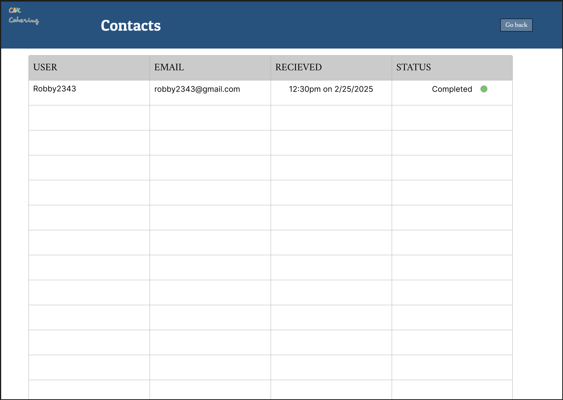

4.15.2 Stimulus/Response Sequences

Staff must click the Contacts button on the homepage to arrive to this screen. Staff may view whether or not a support request has been completed, if not, then they must click on the row to reply and arrive to the support window. To go back to the home screen, click “Go Back in the top right of the screen”.

4.15.3 Functional Requirements

Any customers that have sent support questions will appear in the contacts chart as shown in the picture. It will state when the user submitted the request and if its been completed or not yet.

## Employee: Contacts Support Window

4.16.1 Description and Priority

This tab allows employees to reply to support requests or questions asked by customers.

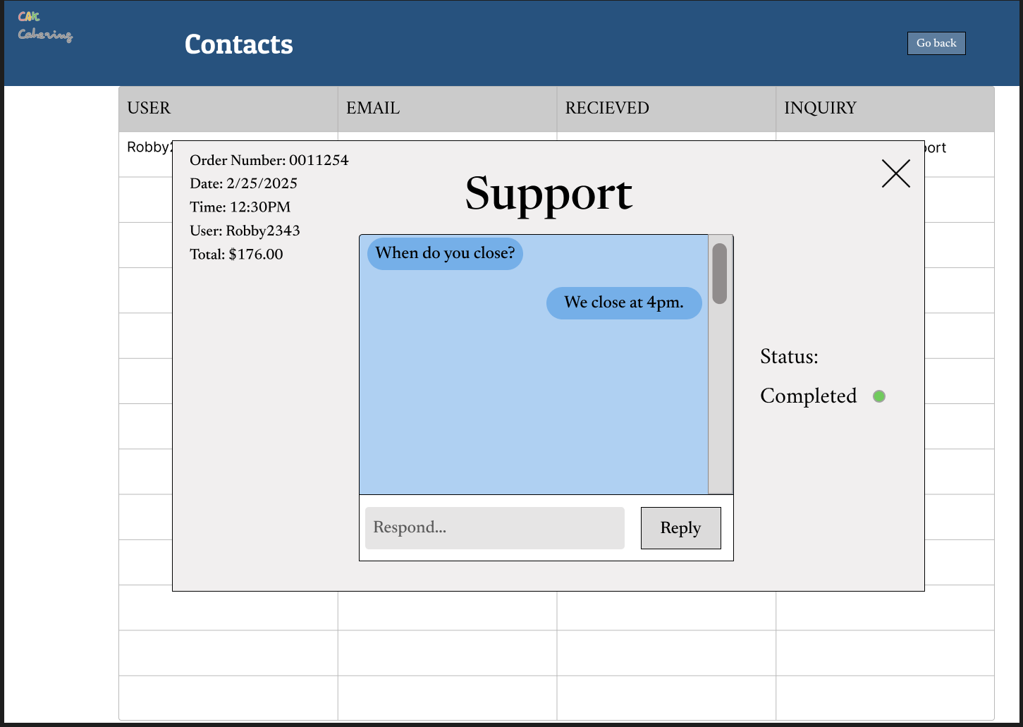

4.16.2 Stimulus/Response Sequences

Staff must hover the row associated with the customers and click on it to enter this tab.Staff may respond to customers' questions and once satisfied, can mark complete on the right. If the chat also extends passed the blue box they may scroll by using the bar to the right of the chatbox. To exit the tab there is an “X” at the top right of the window.

4.16.3 Functional Requirements

A customer must have a question for their to be a support box, employees also can only mark a request completed when the customer is satisfied with their support.

## Employee: Orders Chart

4.17.1 Description and Priority

This feature allows employees to be able to view orders on the chart.

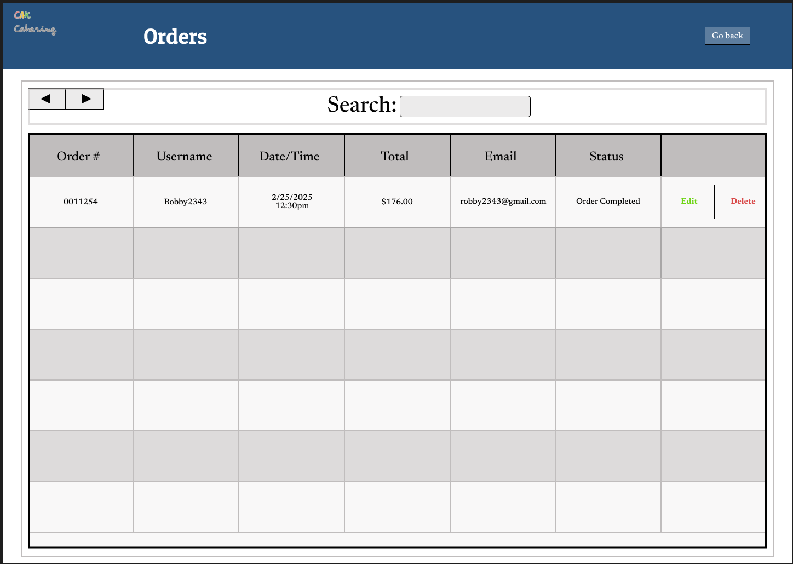

4.17.2 Stimulus/Response Sequences

From the employees homescreen, the user must click the orders button to get to this screen. Users may view orders with their order number, username, the date and time for the order, the total, the customer's email, the status of the order and the ability to edit or delete the order. They may also Search for an order if they cannot find it on the chart. The arrows also allow the user to go to the next page if there are more orders.To go back to the home screen, click “Go Back in the top right of the screen”.

4.17.3 Functional Requirements

Employee cannot manually put in an order, the customer must place an order for it to appear on the screen. They may also only search up orders that are in the chart and database.

## Employee: Order Details within Orders Chart

4.18.1 Description and Priority

This feature allows employees to be able to view order details within the orders chart window.

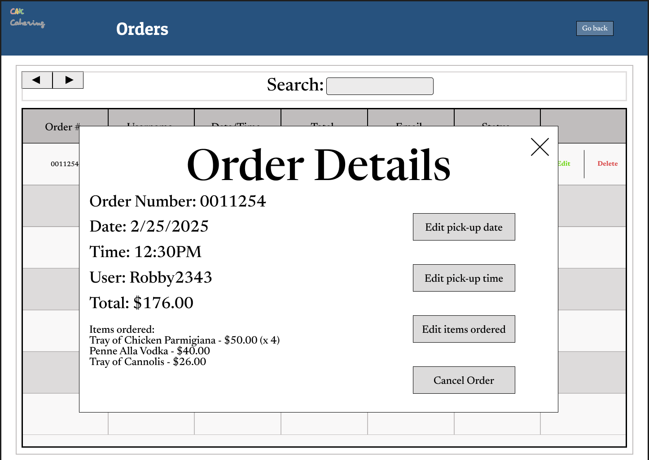

4.18.2 Stimulus/Response Sequences

User must click the edit button to view the order details window. Users will be able to edit the pick up date or time, while also be able to edit the items

ordered by the user. They may also cancel the order within this tab. This will remove

it from the Orders Chart. To exit the tab there is an “X” at the top right of the window.

4.18.3 Functional Requirements

Requires for an order to be placed by a customer so that it can grab information from the database for it to be placed in the window

# **Other Nonfunctional Requirements**

## **Performance Requirements**

CAK Catering requires a system with minimum 8 GB of RAM, intel Core i3 or AMD Ryzen 5. For storage, a solid-state drive(SSD) is recommended along with a graphics card for better performance.

## **Safety Requirements**

In order to avoid losing any of the customer’s orders, CAK catering services are required to be updated regularly by the administrators of the application. It is managed 24/7 for any bugs or handling order dates. A customer chatbot service is enabled for users to communicate with an employee for any of their specific needs, where they are able to report bugs or any-related issues.

## **Security Requirements**

CAK Catering database is managed 24/7 by the administrators to ensure users data is not compromised.

## **Software Quality Attributes**

*CAK Catering offers simple and unique features for customers and employees to navigate through the application with ease. The application is designed to help make users life easier. If a user has a problem with using any features, a customer chatbot service is available for any related questions to help users understand.*

## **Business Rules**

* *Employee:*
  + *can cancel/edit existing orders*
  + *mark orders as picked up*
  + *Get report to determine which ingredient needs to be re-ordered.*
  + *Can access customer chatbot to help customers.*
* *Administrator:*
  + *can add/delete accounts from the database*
  + *can fill order dates for overload management from the calender*
  + *can add items to the menu based on suggestions from the database*
  + *can disable chatbot services if a bug or related issue needs to be fixed.*